Phong Model

📘 Definition
# Source: AI Source: Provided by: [Data Path: Persons Table -> ID Column: 1, Name_En Column: Motasem Essam] -> From: [ChatGPT] on [5/2/2026]
The Phong Lighting Model is a computer graphics technique used to create realistic lighting on 3D objects, including smooth shading and shiny highlights.
It combines different types of light to simulate how real surfaces look.

💡 How Phong Model works
# Source: AI Source: Provided by: [Data Path: Persons Table -> ID Column: 1, Name_En Column: Motasem Essam] -> From: [ChatGPT] on [5/2/2026]
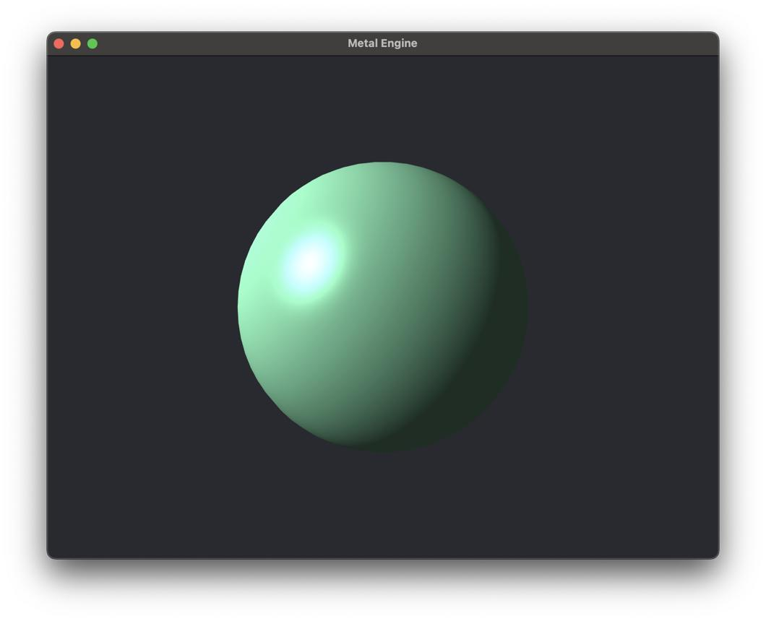
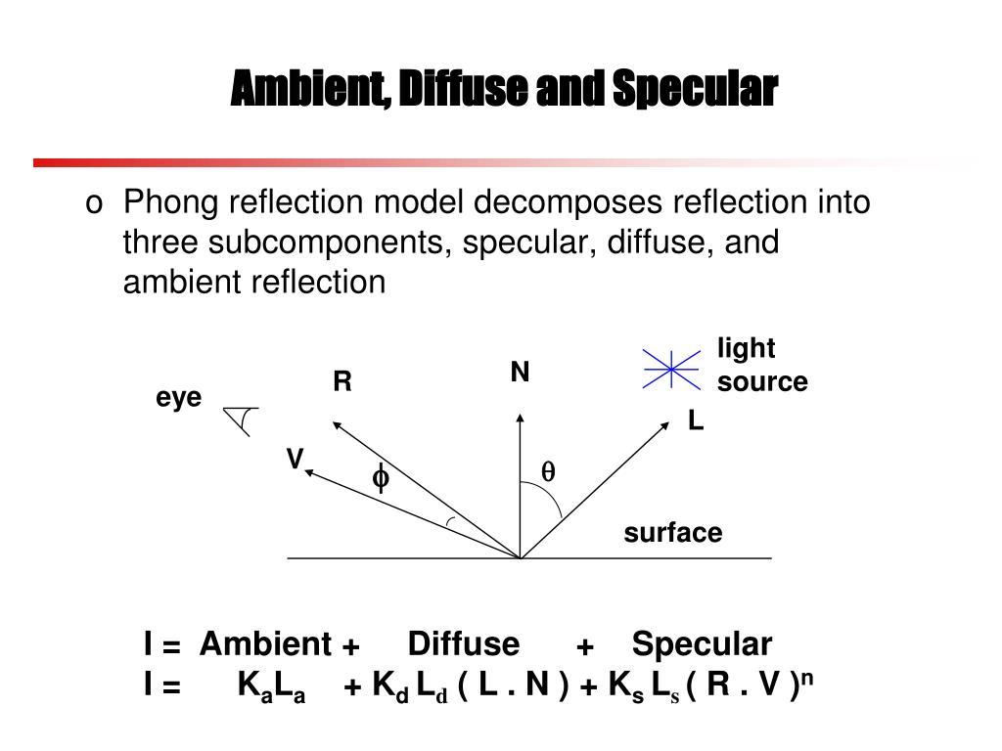
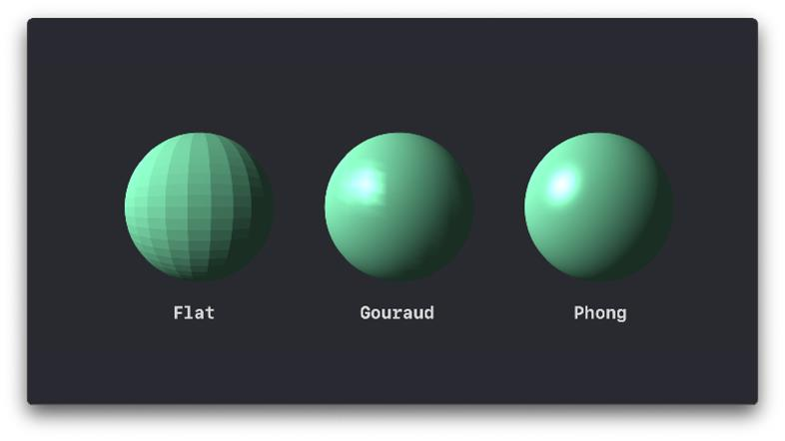
The Phong model uses three components:
- 🌫️ Ambient light → soft light everywhere
- 💡 Diffuse light → light spread on rough surfaces
- ✨ Specular light → shiny highlight on smooth surfaces

🧠 Simple example
# Source: AI Source: Provided by: [Data Path: Persons Table -> ID Column: 1, Name_En Column: Motasem Essam] -> From: [ChatGPT] on [5/2/2026]
Think of a shiny ball under a lamp:
- Whole ball has soft lighting (ambient + diffuse)
- One bright spot appears (specular highlight)
- The rest smoothly fades into shadow

🎮 Where Phong Model is used
# Source: AI Source: Provided by: [Data Path: Persons Table -> ID Column: 1, Name_En Column: Motasem Essam] -> From: [ChatGPT] on [5/2/2026]
- 🎮 Video games (realistic lighting)
- 🎬 Movies and CGI animation
- 🧑‍🎨 3D modeling software
- 🕶️ Virtual reality (VR)

⚙️ Key features
# Source: AI Source: Provided by: [Data Path: Persons Table -> ID Column: 1, Name_En Column: Motasem Essam] -> From: [ChatGPT] on [5/2/2026]
- ✨ Produces shiny highlights
- 🌗 Smooth transitions between light and shadow
- 🧩 More realistic than Lambert model
- 💻 More computationally expensive than simple models

🚀 In short:
# Source: AI Source: Provided by: [Data Path: Persons Table -> ID Column: 1, Name_En Column: Motasem Essam] -> From: [ChatGPT] on [5/2/2026]
Phong Model = a lighting model that creates realistic 3D lighting using ambient, diffuse, and shiny specular reflections.

